

# About this manual

This manual consists of two parts:

* the first part is a tutorial for creating the graphical part of a simple electric trainer
* the second part consists of a list of parameters that applies to the physical flight model.

***Remark:*** *the aircraft you'll create in the tutorial can be downloaded in finished form from the R/C Desk Pilot website.*

# Creating your first aircraft

## Introduction

In this tutorial you'll be creating your first aircraft for R/C Desk Pilot. You'll be flying the first version of your aircraft within 10 minutes of starting this tutorial. After that we'll go into detail on some of the options you have on personalizing both the looks and the feel of your aircraft. Besides an installation of R/C Desk Pilot, nothing is needed to follow this tutorial since all necessary files are included in the installation.

## Starting a new build

When starting the editor, a window appears with an empty scenery. We'll start our new airplane by selecting File > New from the menu.

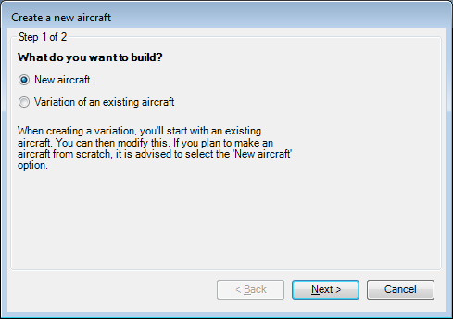

You'll get a small wizard asking if you want to create a whole new aircraft or make a variation of an existing one. We'll go for a 'New aircraft' and click Next.

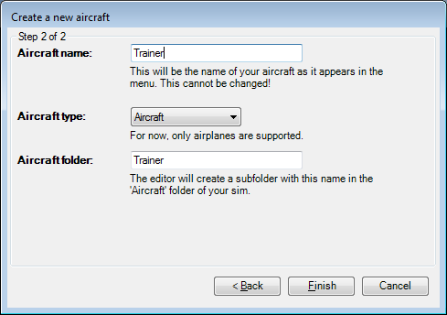

In the second step we'll name our aircraft. Since we'll create an electric trainer, the name 'Trainer' seems appropriate. This is also the name that will appear in the sims' Aircraft menu. When filling in the name, the bottom textbox for folder is also filled in with the same name by default. The second textbox defines the folder in which the aircraft will be created. Giving it the same name as the aircraft is generally a good idea. Click Finish.

## Getting it to fly

### Loading a 3D model

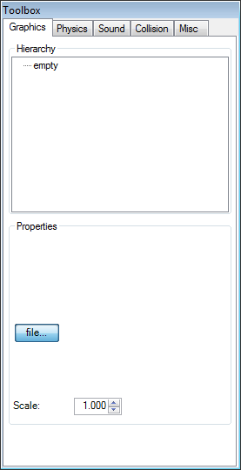After pressing the Finish button, a new dialog will appear. This is the main toolbox for the editor. From here you'll have access to all aspects of the aircraft. The first tab page 'Graphics' controls everything about the aircraft that you see, i.e. the 3D model. It's important to understand that in R/C Desk Pilot the 3D model is completely separated from the actual physical flight model. You could even make a lawnmower fly! Oh wait, that's been done in real life as well...

Anyway, back to our trainer. We'll add our first piece of the 3D model right away. On the top of the Graphics tab, you'll find a treeview with only one element in it at the moment: "empty". This treeview displays the hierarchy of all components of the aircraft, i.e. which (moving) part is connected to which other part. The root element (the one called 'empty' at the moment), is meant for the large part of the aircraft that is 'fixed'. In general this is the fuselage and the fixed part of the wing and stabilizers. You can attach other (non-)moving items to this root element, but your root element determines two important aspects: the position of the center of gravity (CoG) and the scale of the aircraft. This will become clear when building our trainer.

1. Select the 'empty' node in the Hierarchy treeview.
2. Click on the 'file...' button in the Properties section.
3. Browse to the folder named 'Repository' in the R/C Desk Pilot installation folder (default: c:\Program Files\RC Desk Pilot\Repository). It contains all files necessary to complete this tutorial. Select the file 'trainer_fixed.x' and click the 'Open' button. This file contains part of the 3D model we'll use for our aircraft.

***Remark:*** *Upon selecting files in the editor, the editor will copy all files necessary (e.g. textures) into the aircraft folder we've created in the first part of this tutorial.*

For the first time, the outlines of an aircraft appear in the main window of the editor. By holding down your right mouse button, you can rotate the view around the newly imported 3D model. It should look something like this:

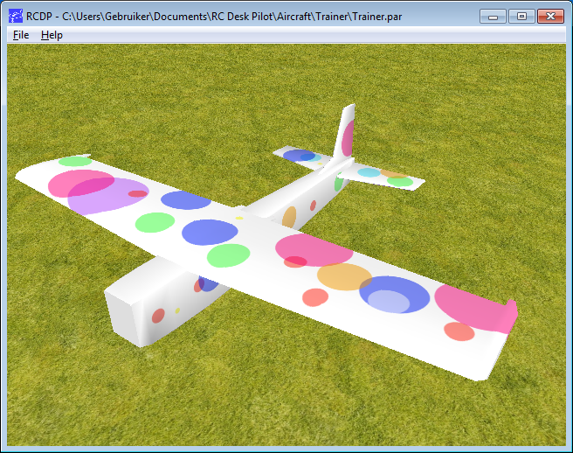

Not the prettiest of airplanes, but it'll do for this tutorial.

***Remark:*** *the origin, or coordinates (0,0,0) of this 3D model should be at the location where you want the CoG to be. All rotations of the 3D model in flight will occur around this point. This has to be set in your 3D editor as it cannot be changed within the Aircraft Editor.*

Go ahead and look at the model from all angles. You can use the scroll wheel of the mouse to zoom in and out. By holding down the scroll wheel you can pan the view. By using the keys F1, F2 and F3, you'll get a sideways, topside or frontal view of the aircraft.

Now go ahead and select the root node again from the Hierarchy treeview. You'll notice it now has a name, 'trainer_fixed'. This was the name of the 3D model we assigned. In the properties section, the text 'S: 1.56, L:1.11' appears. This indicates that at the current scale, the model has a span of 1.56 meter and a length of 1.11 meter. This is slightly too large for our purposes so we'll reduce the scale to 0.7 - giving a span of 1.09 meter.

### Setting the collision points

We are almost ready to testfly our first airplane. The only thing left to do is tell the sim where the extreme points are on our 3D model. This will tell the sim where the 3D model will interact with the ground. For this first try, let's add 4 collision points: one on each wing tip, one at the nose and one at the tail. To do this click 'Add point' next to the 'Collision points' section. This will add a collision point at the CoG. We'll need to move it to the nose. For this, select the point in the Collision points list and click and drag the two buttons with arrows below it. Dragging the left button will move the point in the horizontal plane, the right button will move the point up and down. Since the point is originally at the CoG inside the fuselage, it won't show up immediately. So go ahead and drag it forward in the horizontal plane until it shows up at the nose end. You can hold the SHIFT key to finetune the position of the collision point and the CTRL key to restrict the movement to one axis. Eventually, your point should be somewhere here:



Let's repeat this process for the collision point at the tail, and the left wing. To create the collision point on the right wing, the editor has a handy feature. Select the left wing collision point and click the 'Clone point' button. This will create a symmetric collection point on the right hand side. When all 4 collision points have been created, the view will look something like this:

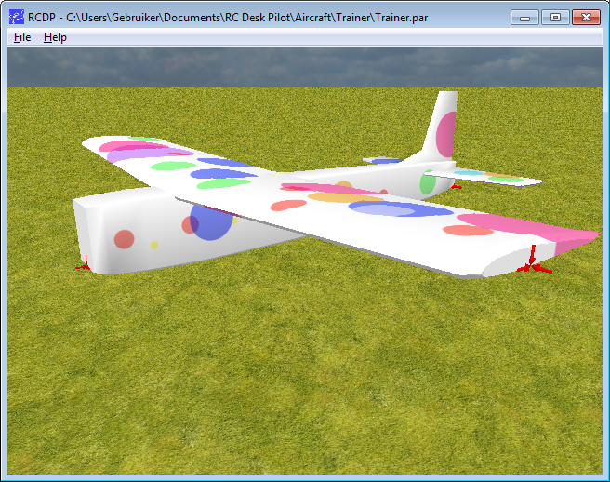

The location of our 4 points are:

(0.000;-0.045;-0.210)  
(0.000;-0.011;0.564)  
(0.545;0.069;-0.010)  
(-0.545;0.069;-0.010)

## Maiden flight!

Hold on a second. Before we can fly the aircraft you'll notice that it doesn't have a landing gear. It's pretty hard to take off from the ground without a landing gear. So for now, we'll have to hand launch the aircraft. To enable hand launch, select the 'Misc(ellaneous)' tab and check the box 'hand launched'.

Now for the flying: select the Physics tab. This is the tab to define the flight characteristics of your airplane. For now the default values will do, so take out your controller and check the box 'Test Fly!'. Your aircraft will be launched and you can do your first test flight!

***Remark:*** *since the Aircraft Editor doesn't have its own control settings, it uses the settings from the actual sim. So make sure you've configured your controls in the sim!*

***Remark:*** *While in flight mode, you can use the '+' and '-' key to zoom in and out.*

If you save this aircraft (File > Save), you can start up the sim and do a testflight from within the sim.

## Adding some parts

Although the aircraft already flies, it sure misses some pretty vital parts, like an engine and control surfaces. Let's return to our Graphics tab to add these.

***Remark:*** *although you can do everything while in test fly mode, it's recommended to switch it off while editing the graphical part of the airplane.*

Let's start by adding an engine.

While in the Graphics tab, right click on the root element (named trainer_fixed) and select 'Add child item' from the context menu that appears.

Select the newly created node (called 'empty'). The Properties section displays a bunch of controls. We'll start by loading a 3D model for the engine.

* Click on the 'file...' button in the Properties section.
* Again browse to the Repository folder in your R/C Desk Pilot installation folder and select the file 'brushless_motor.x'.
* Click 'open'

It will seem like nothing happened. This is because the 3D model of the motor is loaded at the CoG, which is inside the fuselage. Now let's move it into its conventional position:

* Click and drag on the left button next to the 'Position: ' vector. This will move the object within the horizontal plane. Dragging up will move the object forward. When the position vector reaches (0.00;0.00;-0.300), the motor will be in place.

Since the 3D model of the motor isn't animated, we're done with the motor. Now let's add our first control surface, the elevator.

1. Start by adding another child item directly to the root element ('trainer_fixed').
2. Open the 3D model 'trainer_elevator.x' using the 'file...' button.
3. Move it to position (0.00;0.039;0.808) (don't forget to hold the SHIFT key for small movements or the CTRL key to restrict the movement).
4. Now we're ready to animate the elevator. For that select the 'Elevator' in the 'Channel' combobox.
5. Next we have to define the rotation axis. For the elevator, this is sideways. Using the drag controls next to the 'Rot. Axis' vector, move the axis to (0.20;0.00;0.00). Note that it is only the direction that counts, not the size of the vector.
6. Now we can define the throws using the 'Min. angle' and 'Max. angle' values. Let's take -20° for minimum, and +20° for maximum angle.
7. Try it out by moving your controller. If the direction is reversed (depending on the direction of the rotation axis), you can reverse the animation by selecting the 'Reversed' checkbox.



Now as an exercise do the same for the rudder and both ailerons. Note that you can add multiple objects and assign them to the same channel. For example, both ailerons are separate objects but both are assigned to the Aileron channel. In the same fashion, add the steerable nose wheel by assigning it to the Rudder channel and setting the rotation axis completely vertical. Adding the main gear by now is simple as it is a static part of the aircraft.

The propeller is slightly more complicated: we'll need two objects for that. One for the low rpm (a model of a regular prop), and one for the high rpm (a transparent disk). Assign both to the 'Throttle' channel. For both set the rotation axis along the longitudinal axis. This is where the 'Type' combobox comes in: set the normal prop to type 'Prop (low RPM)' and the propdisk to type 'Prop (high RPM)'. You'll see one of them disappear depending on your throttle setting.



There she is! She won't win a beauty contest but she will teach you how to handle airplanes.

***Remark:*** *the meshes of the parts should have one point of their rotation axis in the origin. So you'll probably have to move the individual parts to the origin before saving or exporting the mesh.*

## Setting the sound

You'll notice that the motor never completely stops. Since we're building an electric plane, the engine should come to a complete stop at lowest throttle setting.

The sim gets this setting from the sound parameters. When the minimum frequency equals zero, the sim assumes it's an electric motor and the prop will stop at zero throttle.

Let's set up the sound for our trainer:

1. Open the Sound tab
2. Click the 'file...' button
3. Select the file 'brushless_motor.wav' from the Repository folder.
4. Set the minimum frequency to 0 and the maximum frequency to about 70,000 (or what sounds right to you).

## Updating the collision points

There is one thing left to do before a new test flight. We haven't told the sim where the landing gear is. It's time to go back to the Collision tab.

This time we'll start with adding 'Landing Gear Points' instead of 'Collision Points'. Add three points to the 'Landing Gear Points' section and place them at the bottom of each of the three wheels.

***Remark:*** *Landing Gear Points are marked in green, while the Collision Points are red.*

The reason for dividing the contact points into two sets is that this way, we can define the 'crash resistance' parameters different between the two sets. Usually the gear can take more force than the rest of the airframe.

The 'Bounce' parameter defines the amount the aircraft will 'bounce' upon touchdown.

Now that we've given the aircraft a landing gear, we can uncheck the 'hand launched' checkbox on the 'Misc' tab.

While we're there, write down a small description of your aircraft. This will appear when your aircraft is selected in the aircraft menu of the sim. You can also assign an icon file, which is a 256x256 file displayed in the sim menu. You can a use transparent PNG file here.

## Ready for customizing the flight model

That's it for this part of the tutorial! Your aircraft is a fully functional 3D model and already flying with the default parameters. Now it's time for the most important part: customizing the way the aircraft flies. We won't handle this in a tutorial fashion, as this is different for each aircraft. We'll list all parameters available to customize the flight behavior.

# The flight characteristics

This section handles every parameter available on the Physics tab. This tab defines the behavior of the aircraft in the air.

## Lift & Drag



Behind every button in the 'Lift & Drag' section is a graph of an aerodynamic coefficient. The X-axis of these graphs is the Angle of Attack of the airframe (or Alpha for short). This is the angle with which the airframe moves through the air.

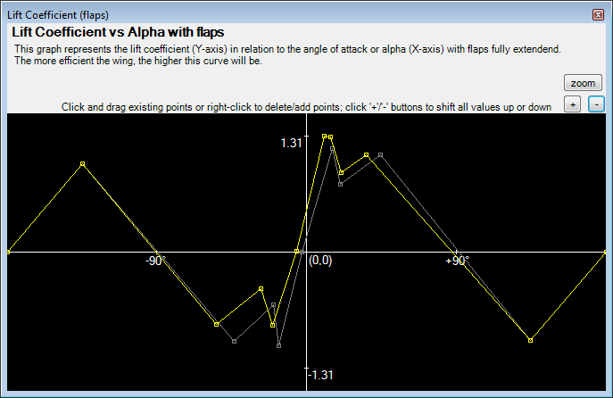

You can edit the graph by clicking on any of the markers and dragging them to the desired position. The selected point will also display the exact values. Right clicking on a point will delete it (as long as there are at least two points left). Right clicking between two points will add a new one. In the case of graphs with flaps, the original graph (without flaps) is displayed in the background for reference. The small '+' and '-' buttons will move the entire graph up or down. You can use these for example in the drag graph to increase or decrease the drag of the aircraft.

***Remark:*** *the coefficient graph will automatically change the scale on the Y-axis according to the largest value.*

The available graphs are:

* *Lift Coefficient*: the lift coefficient of the entire airframe in relation to the angle of attack.
* *Lift Coefficient (flaps)*: flaps will alter the lift coefficient of the airframe (well, that's the purpose of them). This graph depicts the lift coefficient with the flaps fully extended.
* *Sideways Lift Coefficient*: all vertical surfaces of the airframe also generate sideways lift depending on the sideways angle of attack. This graph defines that lift in relation to the sideways angle of attack.
* *Drag Coefficient*: the drag coefficient of the entire airframe in relation to the angle of attack.
* *Drag Coefficient (flaps)*: in general, when flaps are extended, drag increases. This graph allows you to define the drag in case of fully extended flaps.
* *Sideways Drag Coefficient*: the drag coefficient of the entire airframe in relation to the sideways angle of attack.

***Remark:*** *you can use the free tool JavaFoil to calculate information about the lift/drag characteristics of your airfoil.* <http://www.mh-aerotools.de/airfoils/javafoil.htm>

## Agility

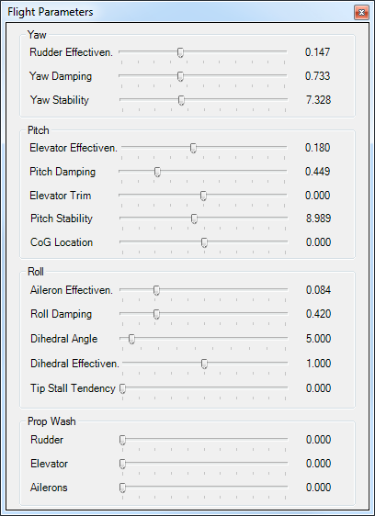

The agility section features one button 'Flight Parameters' which will lead you to a dialog with a number of sliders. All these parameters say something about the manoeuvrability of your aircraft. They are grouped by rotation axis.

* *Rudder Effectiveness*: the amount your rudder will influence the yaw. Note that this will also depend on airspeed.
* *Yaw Damping*: yaw damping is the amount of damping on the yaw rotation, a low yaw rotation will result in yaw oscillations. You can check this parameter by giving full rudder and releasing it suddenly. If the aircraft starts oscillating, this parameter should be increased.
* *Yaw Stability*: yaw stability is the tendency of the aircraft to keep the nose in the direction it is flying. While flying forward, the larger vertical surface behind the CoG keeps the tail in line with the velocity vector.
* *Elevator Effectiveness*: the amount your elevator will influence the pitch.
* *Pitch Damping*: like yaw damping, the amount the pitch rotation is damped.
* *Elevator Trim*: together with the CoG Location, this will determine the trim in the pitch direction.
* *Pitch Stability:* just like yaw stability, the horizontal tail will push the nose of the aircraft down or up to minimize the AoA.
* *CoG Location*: this parameter defines the offset of the Center of Gravity in relation to the Center of Lift. The difference between these two will result in a torque force in the pitch direction. Depending on the lift/drag coefficient, the aircraft might have the tendency to pitch up or down at neutral control input. This parameter allows you to trim that (equivalent to altering the angle of the entire horizontal stabilizer).
* *Aileron Effectiveness*: the amount your ailerons will influence the roll.
* *Roll Damping*: the amount the drag of the wings will slow down roll.
* *Dihedral Angle*: the angle of dihedral of the wing. This in combination with the Dihedral Effectiveness determines the stabile, self-uprighting behavior of the aircraft.
* *Dihedral Effectiveness*: see directly above.
* *Tip Stall Tendency*: the tendency of the aircraft to "drop a wing" when stalling.
* *Prop Wash Rudder/Elevator/Ailerons*: how much the wash of the propeller increases the effect of the respective control surface.

***Remark****: the value of these parameters depend on the Moment of Inertia. It is recommended to first determine the Moment of Inertia before fine tuning the agility parameters.*

## Dimensions



These kind of speak for themselves. They are measured in the metric system. However, the values in the imperial system are displayed for reference.

## Moments of Inertia

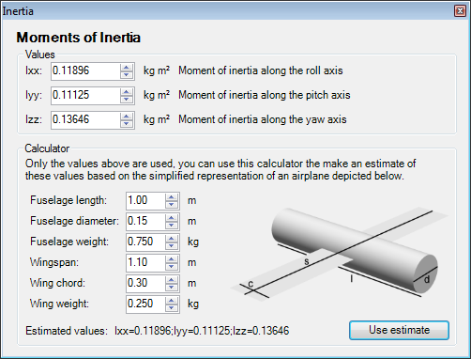

The moments of inertia define the weight distribution of the aircraft around the three main axis. The further away from the rotation axis the weight is located, the larger the moment of inertia around that axis is. It is very difficult to measure the moment of inertia. There are various mathematical formulas available for basic 3D shapes. Using these the editor features a very simple calculator to at least provide an estimate for the values for your aircraft. The calculator uses a simple model of an aircraft of a solid cylinder for the fuselage and a rectangle of no thickness located at the centre of the fuselage to represent the wings. Of course this is an oversimplification, but you are free to use more advanced methods to calculate these values.

## Propulsion

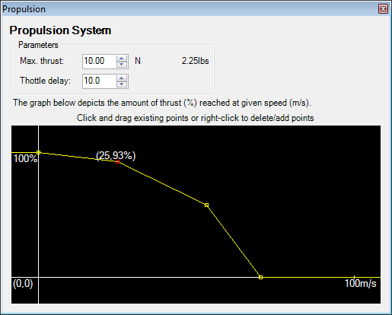

Instead of having to define all parameters available for motor/engine/gear/prop, you only need to provide the result of the entire propulsion system, i.e. the amount of thrust the system generates at which airspeed. The graph uses the same interface as the lift & drag coefficient graphs.

The 'Max. Thrust' is measured in Newtons and corresponds to 100% in the thrust graph.

The 'Throttle delay' parameter defines how quick the engine reacts to inputs.

## Flight model version

You might have noticed the Flight Model Version combobox on the Physics tab.



The 'Basic' flight model will suffice for most airplanes. The 'Advanced' flight model will work better in more extreme aerobatics and will let the plane react more realistically to the wind and thermals but requires more time to set up. Beware that switching between the two will force you to reset some of the agility parameters. After switching to the advanced flight model, open the Dimensions dialog. Some extra parameters will have appeared:

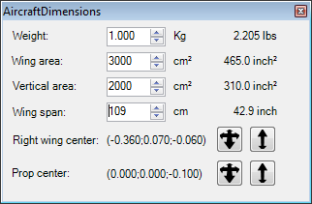

The first three were already present in the basic flight model. What's new are the last three. The wing span speaks for itself. When opening the dialog, two 3D cursors appear on the 3D display. One for the "right wing center" and one for the "prop center".

* **Right wing center**: set this to the approximate center of lift of the right wing. The further out the wing center, the more vulnerable the aircraft will be for gusts of wind and tip stalls.
* **Prop center**: this should only be changed for 3D aircraft. When the angle of attack in these aircraft increases beyond the stall angle, more and more lift is provided by the prop itself. This moves the center of lift forward, making the airplane want to "prop hang". This vector tells the sim where the center of lift is in that case. Moving this further forward will make the plane want to prop hang more. Shift this around until it feels right.

# Packaging and Distribution

## Packaging

When you've finished building and testing your aircraft, you're ready to share your creation with the world.

If you take a look at the 'RC Desk Pilot' subfolder of your My Documents folder, you'll find a subfolder in the aircraft directory named after your newly created aircraft. This folder contains everything that is needed. It is recommended to zip this folder (including the folder itself) and use the zip to distribute your aircraft. People downloading this zip file just need to unzip it into the 'RC Desk Pilot\Aircraft' folder of their My Documents folder. It is possible that in the future R/C Desk Pilot will contain a tool to manage and install new aircraft.

## License

You are free to build and distribute your aircraft as long as they serve no commercial goal. If you have a commercial purpose for distributing the aircraft (be it advertising, selling the physical or virtual aircraft or plans, ...), you are obliged to ask permission at [info@rcdeskpilot.com](mailto:info@rcdeskpilot.com). We have several options to optimize the exposure of your aircraft.

# Bugs and getting help

If you find a bug, it would be appreciated if you reported it to [info@rcdeskpilot.com](mailto:info@rcdeskpilot.com). Before you do, please make sure you've downloaded the latest version from <http://rcdeskpilot.com>. Please include as much information about the bug as possible: a screenshot, how to reproduce it, your system specs,...

If you're stuck or don't know how to model something, don't hesitate to either send me an email at the above address or consult one of the many R/C forums available. I try to frequent the simulator forums of <http://rcgroups.com>, <http://www.rcuniverse.com>, <http://www.rcpowers.com> and <http://www.modelbouwforum.nl>.

Have fun!